# SCOPE OF WORK

* To add and option for map view of the listing in search listing page
* Compare up to 4 from a listing in all the section
* Notification in the form of SMS
* Filling online application form and download/upload form options
* Facilities : Icon based facilities in each listing
* Information Board
* SMS Integration
* Chat Messenger
* Additional features in page 6-8
* The site will be mobile responsive.

MAP VIEW

* User will have an option to switch between map view and normal view
* In the map view the filters will be same as in the normal view
* Result by radius
* Zoom in/zoom out option
* The changes appears on the map based on the selected filters.
* Clicking on the marker in the map the details appears in a popup.
* All the functions associated will be similar to that of normal listing.

COMPARE LISTINGS

* User will have an option to compare up to 4 listings at a time.
* All the listing should belong to same section, ie all should be Daycare or all should be Schools.
* Minimum two should be selected to compare.
* Option to add or remove an entity to or from the compare list.
* The compare page layout will change based on the number of entities compared. It will have a full width layout even if the comparison is between two entities.
* The compare criteria can be changed by admin
* Option to download the result as PDF.

FACILITIES

* The facilities will be listed in the backend and corresponding icons appears in the front end.
* Option to upload faculty image and a text area to fill the faculty details. N number of faculty can be listed but a fixed one will be shown in the front end.
* Student teacher ratio should also be mentioned.
* Tool tip will show the details about the facilities.

INFORMATION BOARD

* Admin can add the content in the information board.
* It can be latest announcements like
  + Results
  + News updates
  + Offers
  + Anything Admin pleases.
* The latest one will be listed on the top.

NOTIFICATION

* User and the owner of the listing will receive notification SMS on top of mail notification they receive.
* SMS gateway integration.

ONLINE CHAT

* Chat module integration

ONLINE FORM FILLING

* User can fill an application form for a school, collage or Daycare through this option.
* The form will be generic and will capture all the details required.
* An option to download a specific form of any organization will also be available.
* The filled for will be received by the said organization and the admin.

**Refine Search(All sub-domain)**

* + By Landmark ( Only Daycare)
  + Rating
  + Recommendation
  + Admission Type: off-line/on-line/entrance test
  + Facilities
  + By state (Only College)
  + By Entrance Exam (Only College)
  + By Duration (Only College)
  + By Type of college( Private, Public)(Only College)
  + By Course Type(Degree, Diploma, Certificate, Distance etc) (Only College)
  + By Type of course( Full time, part-time, distance, Online) (Only College)
  + By Fee (Only College)

**All sub-domain**

1. **Search Bar re-design like Housing.com**

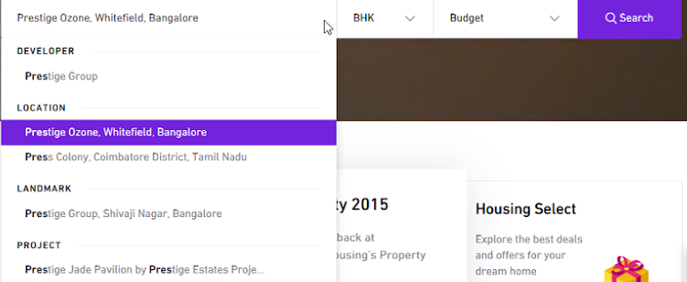

1. **Info page** 
   * + New Tab for Placement , Fee , Faculty**(only College)**
     + New Tab for Excellence/Achievement , Fee , Faculty**(only School)**
2. **Ask Question**

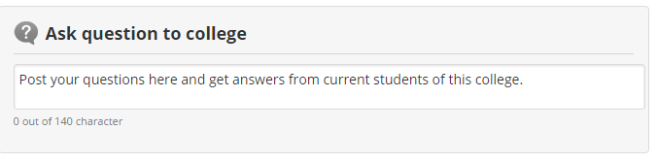

1. **Add to Wish List**
2. **iDiksha Ratings like below on Info Page & Analytics**



**iDiksha Analytics Display on Info Page.**

* This information was last updated on 23/11/2015.
* 5069 students have downloaded brochure.
* Courses have been viewed 2084 times.

1. **Get contact details on SMS Info Page & Realign Address bar.**

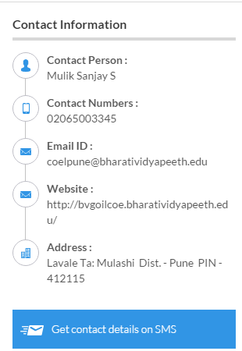

1. **Want to suggest Edit**



1. **Face Book Promotion design like below on Info Page.**



1. **Link to Discussion forum thread**

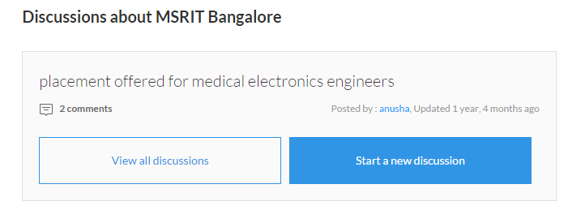

Will just provide a link to connect to the forum page. Will not be exactly like the above image.

1. **Similar/Nearby Sub-domain**

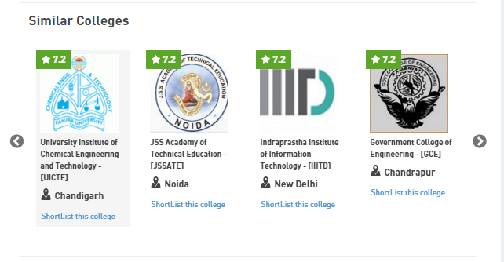

* + Nearby sub-domain

